Crowdfund Solent

Covid-19 impact support fund
for small businesses

CONTENTS
Section Page
- Executive Summary 2

- Background 3

- Fund Overview 4

- Eligibility Criteria and Supporting Information 5

- Application, Decision and Funding Process 7
- Executive summary
The Solent area is an internationally-recognised key economic hub comprising the Isle of Wight, the two cities of Portsmouth and Southampton, and a constellation of large towns along the M27 corridor, New Forest and the Solent waterway.
The Solent Local Enterprise Partnership (LEP) brings together the private and public sectors to support and drive forward business and economic growth, particularly the development and growth of small and medium sized businesses (SMEs).
As the Solent continues to face the 2020 Coronavirus (Covid-19) pandemic, businesses are being severely affected due to closures, decreasing customer demand and supply chain disruptions. Crowdfund Solent has been launched to supplement national Government help for businesses, and ensure the Solent economy stays strong.

Crowdfund Solent aims to assist businesses with cash flow pressures during the Covid-19 pandemic and to work towards supporting recovery plans as Government guidance evolves.

Covid-19 continues to impact micro and small businesses. To ensure these businesses can access essential cash flow now, the Solent Local Enterprise Partnership (LEP) has redirected £600,000 from the local growth small and medium-sized enterprises (SME) fund for micro and small businesses to access using the Crowdfunder platform.

The Solent area is home to over 41,000 businesses, 89% of which are micro (1-9 people) and 9.3% are small (10-49 people).

How does it work?

- The micro or small business set up a campaign on Crowdfunder. This enables them to either:
- pre-sell goods or services, and to diversify their offer in order that they can continue to trade and stay connected with their customer base,
- to ask for donations from loyal customers and supporters.
- The micro or small business begins to crowdfund towards their financial target (that they set). Donors fund goods or services in advance, or donate through good will, helping businesses continue to trade through periods of lockdown.
- Once the Crowdfunder campaign has been set up, eligible businesses will be abel to apply for match-funding from the Solent LEP.
- Once the first 25% of the financial target is met by at least 10 different donors, and if the application is approved in line with the eligibility criteria, the Solent LEP will pledge its match-funding amount.
- Businesses receive coaching support by Crowdfunder to help them reach their target. Once 100% of the target is reached, the Solent LEP pledge is released to the micro or small business.

About Crowdfund Solent

Crowdfunder is covering all platform and transaction fees making it 100% free to small businesses. Where needed, Enterprise Nation is providing access to free training and support for business, to help with online sales, marketing, cash flow, and diversification.

2. Background

2.1 The Solent Local Enterprise Partnership

The Solent LEP is the key interface and lead for economic development in the Solent, an area (See map below) that stretches from Hayling Island in the east, to the New Forest in the west, and includes the Isle of Wight and the two cities of Portsmouth and Southampton. The local authority areas covered by the Solent LEP are as follows:
- Isle of Wight
- Portsmouth
- Southampton
- New Forest
- Eastleigh
- Havant
- Fareham
- Gosport

The Solent LEP is a partnership organisation between the business community, the Further Education and Higher Education sectors, three unitary authorities, ﬁve district councils and one county council.

Collectively, these organisations are actively working together to secure a more prosperous and sustainable future for the Solent area, providing the resources and economic environment which makes it easier for businesses and individuals to be productive, and where pioneering research is encouraged through support for relevant institutions.

For further information on the Solent LEP, please visit our website www.solentlep.org.uk

2.2 The Solent Economy and Business Support

The Solent economy generates just over £31 billion of gross value added (GVA); up from £25.6 billion in 2010. The SME business base has been a key component in this growth, illustrated in 2016 when 9,100 new enterprises were ‘born’ in the Solent LEP area cumulatively; an increase of 69.8% on the total born in 2010. Over the same period the annual rate of enterprise births in the South East increased by 51.6%, falling behind the Solent LEP areas individual growth. In addition to this, the Solent LEP area contributed a sizeable 20.5% of the net gain in enterprises recorded in the South East in 2016.

We are now seeking to support our SMEs through Crowdfund Solent, which aims to support businesses that have been impacted by the Covid-19 pandemic.

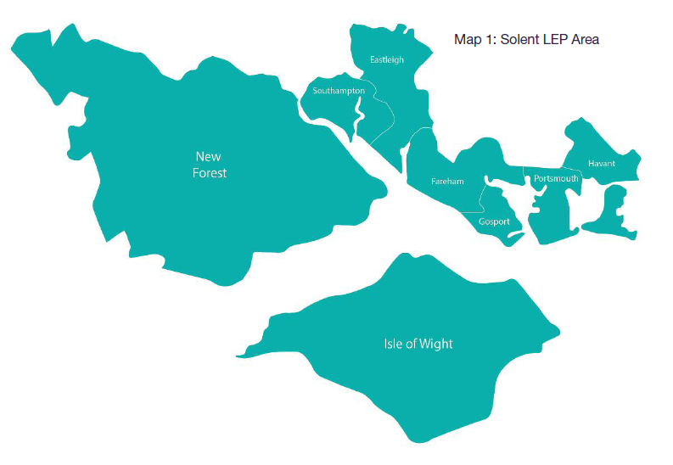
3. Fund Overview

Crowdfund Solent aims to provide opportunities for existing micro and small businesses seeking to cope in challenging trading conditions as a result of the Covid-19 pandemic.

Crowdfund Solent is an open call to all micro and small businesses that can demonstrate how taking part will help them to cope with current challenging trading conditions. There is a maximum of up to £2,000 per micro business (fewer than 10 staff FTE) and up to £5,000 per small business (fewer than 50 staff FTE) available, contributing up to 50% towards the total project costs.

The fund is open from 10 November 2020 until further notice. To apply please follow the guidelines in section 5. You will need to set up a Crowdfund page for your business or project, apply for the Solent LEP match-funding, and achieve at least 25% of your target from a minimum of 10 different donors to enable you to receive the Solent LEP match funding pledge.

If you would like to discuss any element of this fund beforehand, please contact the Solent Growth Hub team at enquiries@solentlep.org.uk or call 023 9268 8055 to book an appointment.

4. Eligibility Criteria and supporting information

4.1 Eligibility criteria
In order to apply to Crowdfund Solent, every applicant must:
- Qualify as a micro or small business (Social Enterprises, Community Interest Companies and charities engaged in economic activity are also eligible) as per the EU Definition available at: https://ec.europa.eu/growth/smes/business-friendly-environment/sme-definition_en
- Be an existing business with a sound trading history. This will be assessed by financial experts.
- If they are freelance or self-employed, they will need to evidence that they have been operating for at least 12 months.
- Demonstrate that their business has been adversely affected by Covid-19.
- Identify clearly that the Solent LEP funding will be used to support:
  - existing unavoidable costs if their business has had to temporarily close or;
  - costs that are incurred in enabling the business to pivot to new delivery models or routes to market, such as a taking the business online; or
  - costs that are essential in order for their business to be able to start to recover / reopen in line with Government guidance.
- Clearly explain how, with the help of the Solent LEP funding, their business will deliver direct economic benefit within the Solent area.

- Be located in the Solent area. A map of this area can be found at: https://solentlep.org.uk/the-solent/map/

Other Solent LEP funding
- Businesses will not be eligible to apply for support from Crowdfund Solent if:
  - The business has already received Solent LEP funding for a project which is still live (i.e. has LEP funds yet to be drawn down, or contracted outputs yet to be delivered or have yet to complete and submit a satisfactory evaluation form), or;
  - they have been awarded funds from a Solent-based local authority running their own Crowdfunder match funding scheme.
- If the business has received Solent LEP funding for a project which has already been delivered in its entirety (all LEP funds drawn down, all contracted outputs delivered and satisfactory evaluation report submitted) they will be eligible to apply for support from Crowdfund Solent.

Party Political Activity
- The Solent LEP administers all funding in accordance with the National Local Growth Assurance Framework. In line with this framework the Solent LEP has a responsibility to ensure when using or authorising the use by others of the resources of the Solent LEP, that such resources are not used improperly for political or personal purposes (including party political purposes). On this basis, organisations whose purpose is related to party political activity will not be eligible for Solent LEP funding.

  - Timeframe for Delivery

- Businesses applying for Crowdfund Solent must deliver the project between November 2020 and March 2021. Please also note that any costs incurred prior to the submission of their application are sunk costs and cannot be included in the total project costs.
- Applicants must demonstrate through their application and supporting information that they have the resources, expertise and ability to carry out the project within this timescale.

  - Bid Thresholds and Intervention Rates

- Applications from micro businesses (fewer than 10 FTE staff) must be seeking up to a maximum of £2,000 of funding support.
- Applications from small businesses (between 11 and 49 FTE staff) must be seeking up to a maximum of £5,000 of funding support.
- Funding support of up to 50% can be applied for up to the maximum grant values detailed above. Please note all project costs must be incurred directly by the organisation that is applying for the Solent LEP funding, and not subsidiary or related companies.

  - Trigger Points for LEP funding

- The application for Solent LEP funds can be made as soon as the Crowdfund Solent campaign has been set up.
- The campaign must achieve a minimum of 25% of the funding target, which must have come from at least 10 different backers, to trigger the Solent LEP funding pledge.
- The Solent LEP match-funding can only be applied for against the original target. If the business adds a stretch target, the Solent LEP match funding will not change as a result.
- The campaign must achieve the total project target (at least 100%) to receive the Solent LEP funds.

Once the applicant has set up their Crowdfunder page, made it live, and demonstrated that they meet the criteria for the Solent LEP fund, they will be directed to an online form to complete. The application will be reviewed by the Solent LEP team and we will be in touch to discuss this further with them. Please see the next section for further detail.

4.5 Publicity

The Solent LEP will seek to support all businesses approved for match-funding through social media channels. All businesses supported through Crowdfund Solent are obliged to work with the Solent LEP on all appropriate publicity.
5. Application, Decision and Funding Process

5.1 Fund Application

The match-funding application, once received, will be assessed by the Solent LEP Executive who will review the application and supporting information, and decide if it meets the criteria set.
As part of this assessment, the applicant may be asked for additional information to support their application. As the LEP funding is public funding there is a requirement for proper and proportionate due diligence.
Businesses will be required to accept the fund terms and conditions (set out in this technical guidance document) as part of the application for Solent LEP match-funding.
If there are more applications which meet the eligibility criteria than funds available, then the Solent LEP Executive will decide which of the businesses should be awarded a pledge of Solent LEP funds.
They will be contacted with a decision on the application. If we are not match-funding the business, then it will need to be fully-funded by pledges/donations from supporters.
The decision of the match-funding assessors is final. There is no provision to appeal.
If the business' application meets the criteria and is awarded match-funding, then they will be contacted to confirm the amount. We will then update the business' Crowdfunder page to include our pledge and revise the fundraising target that the crowd must meet. The business must then continue to fundraise until this target is reached. If the target is not reached, they will not be able to receive match-funding from the Solent LEP.
5.2 State Aid

Pledges from Crowdfund Solent will only be made where they are compatible with State Aid legislation. These funds are being offered as de minimis aid, and any businesses supported will need to confirm that they have not been in receipt of other de minimis aid that would result in their business exceeding the EU threshold of €200,000 over a rolling three-year period.
5.3 Project Delivery

The businesses can begin to deliver the goals identified in the application at their own financial risk as soon as the application for the Solent LEP match-funds has been submitted. Pledges from the crowd will be held in an escrow account. Where the Solent LEP has made a pledge, match-funds will be released to the business by Crowdfunder once their campaign has closed and they have raised 100% of the target.
5.4 Release of funds

The release of match-funds is subject to the crowd-funding target being reached. Match-funding pledges are released using MangoPay. To receive the pledged money, the project lead is required to set up an account so that funds can be transferred.
If they have set a stretch target, the amount that the Solent LEP will match-fund will not change as a result.
5.5 Project evaluation

Once any match-funded project has been delivered we will require the applicant to provide an update on progress and to carry out a simple evaluation of the outcomes. This is to highlight the benefits the scheme has delivered and to assure the Solent LEP that match-funding was used to achieve the objectives outlined in the application. It is also a useful way of recording any additional outcomes that the funding has supported. This will be sent to the applicant at around three months, or at their request if they would prefer to receive it sooner.

Project timings are dependent upon general Covid-19 guidance from Government, which will be kept under review by Solent LEP.

